

Disclosure Desk SOP
POLICIES & PROCEDURE

Abstract:
This SOP walks the user through the process of Disclosing Initial & COC/LE
Disclosures.
All Western Mortgage| Branch NMLS # 14210 | 8345 W. Sunset Road #380 | Las Vegas, NV 89113
Revision History
Sr. No. Version # Change Summary Section# Approved By & Date Released By & Date 1 1

Page 1 All Western Mortgage| Branch NMLS # 14210 | 8345 W. Sunset Road #380 | Las Vegas, NV 89113
Index
Sr. No. Topic Page no 1 Encompass Login & Disclosures Desk Queues 4 – 5 2 Procedure to open file & mandate check points 6 - 8 ₃ List of forms to verify updated data in ENC & data requiring
updates for initial disclosures 9 - 40 4 2015 Itemization 41 - 51 5 Cash to Close check & match 52 - 53 6 VA Management Form 54 - 55 7 Settlement Service Provider List 56 - 59 8 Mavent 60
9 ATR/QM Management 61 10 Texas State File 62 11 Change of Circumstances (COC/LE) 64 - 71 12 Order the Disclosure Package for both ID & RD (COC/LE) 72 13 Special Instructions 73 14 Notes to Remember 74 15 Basic information of Conventional, FHA & VA Loan 75 - 79 16 Basic information on IRRRL, USDA & DPA Loan 80 – 84 17 Amortization & its Type 85 - 86 18 Basic information on Construction Loan 87- 88
19 | Basic information of Buydown | 89 - 90

Page 2 All Western Mortgage| Branch NMLS # 14210 | 8345 W. Sunset Road #380 | Las Vegas, NV 89113
20 Lender credit & Credit for Rate 91 - 93

Page 3 All Western Mortgage| Branch NMLS # 14210 | 8345 W. Sunset Road #380 | Las Vegas, NV 89113
How to login to Encompass :
Double click the encompass application located on the desktop.
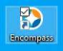
Enter your User ID and password and hit on the Log in button. Make sure the Server (Instance ID - BE11207984) information is correctly filled in.
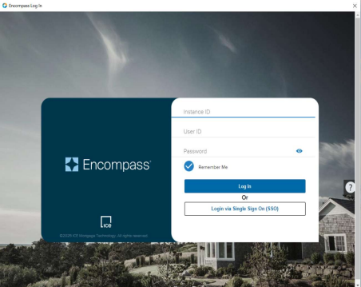
Page 4 All Western Mortgage| Branch NMLS # 14210 | 8345 W. Sunset Road #380 | Las Vegas, NV 89113
Below are the Disclosures Desk Queues:
1. DD Request
2. DD Corrections
3. DD Approved to Send
4. DD LO To Review / Corrections Needed
5. DD Locked Loans
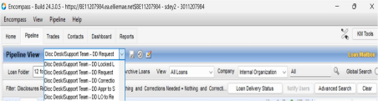
Page 5
All Western Mortgage| Branch NMLS # 14210 | 8345 W. Sunset Road #380 | Las Vegas, NV 89113
1. Select DD Requested Queue:
2. Double-click on Loan Number:
o Locate the loan number to review.
o Double-click on the loan number to open the file.
3. Open the Loan File:
o The loan file will open, showing the associated information and tabs.
4. Navigating the Tabs:
o At the bottom left-hand corner of the screen, you will see three tabs: ▪ Forms
▪ Tools
▪ Services
5. Adjust Display Settings:
o Under these tabs, select “Show in Alpha Order” to arrange the items alphabetically. o Then, select “Show All” to display all available options.
6. Accessing Forms Tab:
o Click on the Forms tab to access the forms section.
7. Go to Disclosure Summary:
o Under the Forms tab, locate and click on Disclosure Summary.
8. Check for Comments/Notes:
o Review the Disclosure Summary for any comments or notes related to the loan. o Make sure all required actions or follow-up tasks are noted and addressed as necessary.
9. For all state Initial Disclosures, ensure that Company License #204 is updated in ENC by navigating to: Tools tab → File Contact → Category/Role → Lender.
Refer to the attached screenshot for guidance.
Page 6 All Western Mortgage| Branch NMLS # 14210 | 8345 W. Sunset Road #380 | Las Vegas, NV 89113
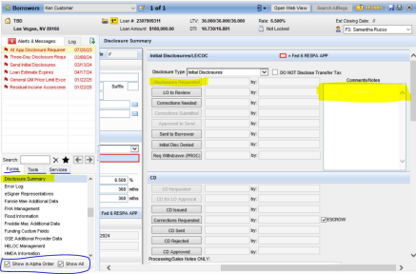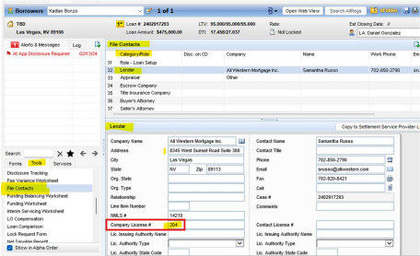
Page 7
All Western Mortgage| Branch NMLS # 14210 | 8345 W. Sunset Road #380 | Las Vegas, NV 89113
1. Accessing Disclosure Tracking:
o Navigate to the Tools Tab in the system.
o Select Disclosure Tracking to monitor the disclosure process.
2. Checking Disclosure History:
o Under Disclosure Tracking, review the Disclosure History.
o For Initial Disclosures, the history should be blank if no disclosures have been sent. o Under the Alerts & Messages tab, there must be an alert titled "Send Initial Disclosures" if the initial disclosure has not been issued yet.
3. Updating the Application Date:
o The Application Date must be updated in the Disclosure Tracking section. This is crucial for tracking deadlines and ensuring compliance.
4. LE Due Date Requirement:
o The Loan Estimate (LE) due date should be set within 3 business days from the Application Date. This ensures timely compliance with disclosure requirements. 5. View if required documents are available under ENC eFolder depend upon Disclosures Requested.
Case 1: Locked Loans
1. Updating TRID Information:
o Ensure that all TRID (TILA-RESPA Integrated Disclosure) information is fully updated in the loan file. Key fields include:
▪ Subject Property Address
▪ DTI (Debt-to-Income Ratio)
▪ Appraised Value / Estimated Value
2. Generating Alerts:
o Once all TRID information is updated, the system will generate the "Send Initial Disclosures" alert under Alerts & Messages.
o If any required TRID information is missing, the system will not generate the "Send Initial Disclosures" alert.
o To trigger the alert, ensure all the required information (listed above) is entered correctly.
Case 2: Non-Locked Loans
1. Monitor Application Date & LE Due Date:
o If the Application Date and LE Due Date have passed, but no disclosure has been sent, then the new loan application needs to be created and inform the Supervisor immediately.
o If Loan is locked then the Supervisor should review the situation and take appropriate action to resolve any delays or issues related to initial disclosures.
Page 8 All Western Mortgage| Branch NMLS # 14210 | 8345 W. Sunset Road #380 | Las Vegas, NV 89113
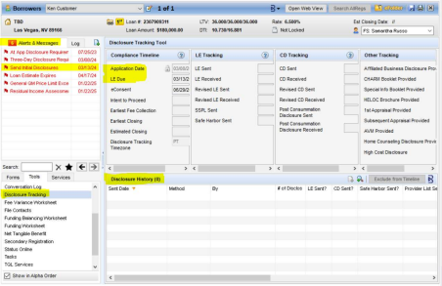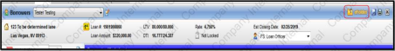
Page 9 All Western Mortgage| Branch NMLS # 14210 | 8345 W. Sunset Road #380 | Las Vegas, NV 89113
1003 URLA – Lender Form
1. Access the Forms Tab: In the system, go to the Forms Tab.
2. Select 1003 URLA - Lender Form: Click on 1003 URLA - Lender Form to open the form. 3. Ensure Fields Are Not Blank:
o Review all pages of the 1003 URLA form.
o Make sure the highlighted fields are not blank on page.
4. Update MIP/FF Based on Loan Type:
o For Conventional Loans:
▪ If the Loan-to-Value (LTV) ratio is greater than 80%, the MIP must be
updated.
▪ If MIP is not updated, request the branch to update it.
o For FHA Loans:
▪ Follow the FHA Matrix to ensure the MIP is updated as per FHA guidelines. o For VA Loans:
▪ The VA Funding Fee (FF) status is updated based on the borrower's
Certificate of Eligibility (COE).
o For USDA Loans:
▪ Ensure that the Upfront MIP (UFMIP) and Annual MIP are correctly updated. ▪ UFMIP is generally 1% of the loan amount and can be financed into the loan. ▪ Annual MIP is based on the loan's term and amount.
5. Homeownership Education and Housing Counselling: Information must be updated to generate Supplemental Consumer Information Form.
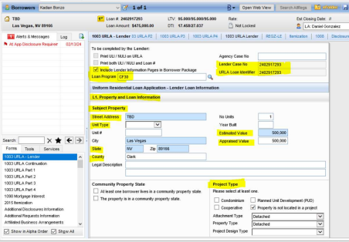
Page 10 All Western Mortgage| Branch NMLS # 14210 | 8345 W. Sunset Road #380 | Las Vegas, NV 89113
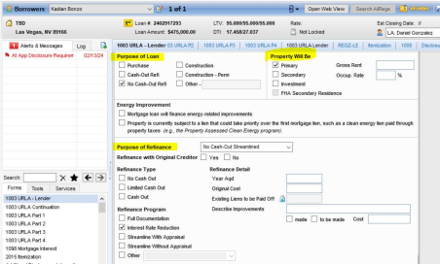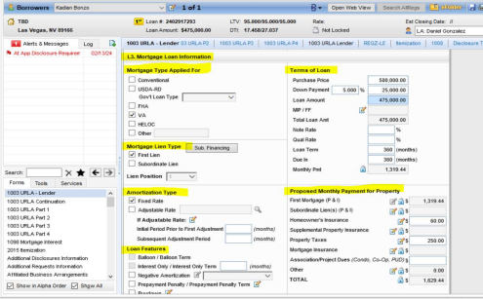
Page 11 All Western Mortgage| Branch NMLS # 14210 | 8345 W. Sunset Road #380 | Las Vegas, NV 89113
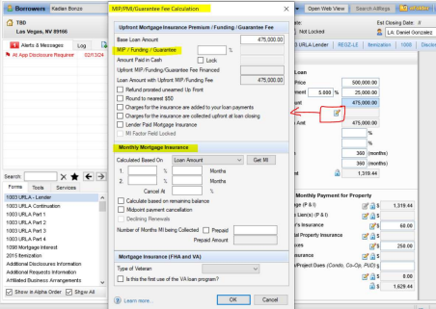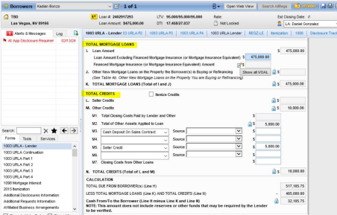
Page 12 All Western Mortgage| Branch NMLS # 14210 | 8345 W. Sunset Road #380 | Las Vegas, NV 89113
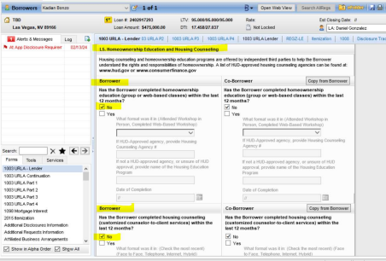
Page 13 All Western Mortgage| Branch NMLS # 14210 | 8345 W. Sunset Road #380 | Las Vegas, NV 89113
1003 URLA Part 1 :-
1. Open 1003 URLA Part 1: Access 1003 URLA Part 1 in the system.
2. Ensure Highlighted Fields Are Not Blank:
o Review all fields on the page.
o Make sure the highlighted fields are not blank.
3. Check Mailing Address Section: Make sure the option "Same as Current" is marked.
Page 14 All Western Mortgage| Branch NMLS # 14210 | 8345 W. Sunset Road #380 | Las Vegas, NV 89113
Page 15 All Western Mortgage| Branch NMLS # 14210 | 8345 W. Sunset Road #380 | Las Vegas, NV 89113
1003 URLA – Part 2: Access 1003 URLA – Part 2 in the system.
1. Review of Borrower's Employment and Income Information:
o Verify the information reflects the borrower’s Current Employment, Self-Employment, and Additional Employment.
o Ensure that the Income from these sources is accurately filled out.
2. Check Gross Monthly Income:
o Make sure the Gross Monthly Income is updated and reflects the correct figures. 3. Review Previous Employment and Income:
o Ensure the Previous Employment and Income are listed if applicable.
4. Verify Total Income:
o Check that the Total Income is correctly calculated and reflects all sources of income.
1003 URLA – Part 3: Access 1003 URLA – Part 3 in the system.
1. Review Borrower's Financial Information – Assets and Liabilities:
o Ensure that the Assets and Liabilities sections are filled out accurately, including all relevant financial details.
2. Review Borrower's Real Estate Information:
o Verify that the Real Estate section reflects the borrower’s current real estate holdings and related financial details.
Page 16 All Western Mortgage| Branch NMLS # 14210 | 8345 W. Sunset Road #380 | Las Vegas, NV 89113
1003 URLA – Part 4: Access 1003 URLA – Part 4 in the system.
1) Update Declarations Information: Ensure all Declarations fields are accurately updated with the borrower’s information.
2) Update Demographic Information: Ensure that the Demographic Information (Ethnicity, Race, Sex) is filled out correctly.
3) Update Loan Originator Information:
a) Make sure the Loan Originator Information is correctly entered.
b) Verify that the Loan Originator Information matches what is listed in the NMLS Portal. 4) Check Loan Originator Authorization:
a) Confirm that the Loan Originator (LO) is authorized to conduct business in the state where the subject property is located.
5) Verify Loan Originator License:
a) Ensure that the Loan Originator’s license is approved and renewed for the current year. 6) Verify the Subject Property Address State:
a) Verify that the subject property's address state and the Loan OƯicer’s (LO's) branch address location are authorized to conduct business.
Page 17 All Western Mortgage| Branch NMLS # 14210 | 8345 W. Sunset Road #380 | Las Vegas, NV 89113
Page 18 All Western Mortgage| Branch NMLS # 14210 | 8345 W. Sunset Road #380 | Las Vegas, NV 89113
Page 19
All Western Mortgage| Branch NMLS # 14210 | 8345 W. Sunset Road #380 | Las Vegas, NV 89113
AƯiliated Business Arrangements Form:
1. Open the AƯiliated Business Arrangements Form: Access the AƯiliated Business Arrangements Form in the system.
2. Check Settlement and Transaction Type:
o Ensure that the Settlement box is marked correctly.
o Confirm that the Purchase/Sale/Refinance box is properly marked.
Page 20 All Western Mortgage| Branch NMLS # 14210 | 8345 W. Sunset Road #380 | Las Vegas, NV 89113
Borrower Summary – Origination:
o Access the Borrower Summary – Origination page in the system.
2. Ensure Highlighted Fields Are Not Blank:
o Review all the highlighted fields on the page.
o Make sure none of the highlighted fields are left blank.
3. Update Channel Information:
o Ensure the Channel field is updated with the appropriate information.
4. Update Current Status of File:
o Verify that the Current Status of File is updated. This will only work for Active loans. 5. Update Application Date:
o Ensure the Application Date is filled out correctly.
6. Update Lock Dates (if applicable):
o If the loan is locked, ensure that the lock dates are updated accordingly in the system.
Page 21 All Western Mortgage| Branch NMLS # 14210 | 8345 W. Sunset Road #380 | Las Vegas, NV 89113
Page 22 All Western Mortgage| Branch NMLS # 14210 | 8345 W. Sunset Road #380 | Las Vegas, NV 89113
Page 23 All Western Mortgage| Branch NMLS # 14210 | 8345 W. Sunset Road #380 | Las Vegas, NV 89113
FACT Act Disclosure Form:
1) Search for Credit Report in eFolder.
2) Update the following fields for all Credit Bureaus (Experian, TransUnion, Equifax) under Fact Act Disclosure Form:
• Credit Score
• Key Factors
• Date Ordered
• Credit Bureau Address
NOTE:-
• The Credit Report ordered date must be on or prior to the application date. • The Credit Score field is greyed out and cannot be updated.
• Your Credit Score Ranks Higher Than % of U.S. Consumers must be updated.
Page 24
All Western Mortgage| Branch NMLS # 14210 | 8345 W. Sunset Road #380 | Las Vegas, NV 89113
Page 25
All Western Mortgage| Branch NMLS # 14210 | 8345 W. Sunset Road #380 | Las Vegas, NV 89113
NOTE: If Fact Act Disclosure form is blank, then notify LO & Processor to pull Credit report for Borrower and upload it in eFolder.
Page 26 All Western Mortgage| Branch NMLS # 14210 | 8345 W. Sunset Road #380 | Las Vegas, NV 89113
Home Counselling Providers:
1. Click on "Get Agencies".
2. Select the first 3 Service Names starting with "F".
3. Select the first 3 Service Names starting with "P".
4. The borrower’s address and Distance must be updated.
5. Click on "Get Agencies".
6. The Home Counsellor List will appear.
7. Click on "Save".
Page 27
All Western Mortgage| Branch NMLS # 14210 | 8345 W. Sunset Road #380 | Las Vegas, NV 89113
Page 28
All Western Mortgage| Branch NMLS # 14210 | 8345 W. Sunset Road #380 | Las Vegas, NV 89113
Page 29
All Western Mortgage| Branch NMLS # 14210 | 8345 W. Sunset Road #380 | Las Vegas, NV 89113
HUD 1003 Addendum: Applicable/update only for FHA & VA Loans
1) Select Agency Name based on Loan type (FHA or VA).
2) Update Agency Case #.
3) Update Lender I.D. Code based on Loan type.
4) For FHA Loan:
• Update Question 22a in Part IV Borrower Certification.
• Update Question 25 in Part IV Borrower Certification.
Page 30
All Western Mortgage| Branch NMLS # 14210 | 8345 W. Sunset Road #380 | Las Vegas, NV 89113
Page 31
All Western Mortgage| Branch NMLS # 14210 | 8345 W. Sunset Road #380 | Las Vegas, NV 89113
RegZ – LE:
1. Under RegZ – LE Form:
o Update LE Date Issued with Current/Present Date.
2. Check if Buydown is marked under Buydown Mortgage tab.
o If marked, the following fields must updated:
▪ Contributor
▪ Buydown Type
▪ Rate %
▪ Term
3. Click on Buydown Disbursement.
o Check for Buydown funds amount and update the same Buydown funds amount under the 2015 itemization form.
4. Interest Accrual Options:
o Ensure 0% Payment Option is blank.
o Set Interest Days/Days in a Year to 360/360.
o Ensure Use Simple Interest Accrual is blank.
o Set Number of Days (Biweekly, Interim Interest, Classic HELOC) to 365.
5. Prepayment:
o If Prepayment updated as ‘Will not, May not’, proceed as-is.
o If Prepayment updated as ‘Will, May, May be’, click on Prepayment Penalty tab, following fields must update:
▪ Type of Prepay
▪ Prepayment Period
▪ Prepayment as a %.
6. Late Charge:
o Click on Get Late Fee.
o For Conventional, update as 15 Days, 5%.
o For FHA/VA, update as 15 Days, 4%.
o The late charge fee reflected on the LE page 3 for North Carolina is to read 4% for all loan types.
7. Assumption:
o For Conventional, update as ‘may not’.
o For FHA/VA, update as ‘may, subject to conditions.
Page 32 All Western Mortgage| Branch NMLS # 14210 | 8345 W. Sunset Road #380 | Las Vegas, NV 89113
Page 33
All Western Mortgage| Branch NMLS # 14210 | 8345 W. Sunset Road #380 | Las Vegas, NV 89113
Page 34
All Western Mortgage| Branch NMLS # 14210 | 8345 W. Sunset Road #380 | Las Vegas, NV 89113
Request for Transcript of Tax (Classic):
1) Tax Form is for:
• If a single borrower is on the loan application, select “Borrower.”
• If two borrowers are on the loan application, select “Both.”
2) Select 4506-C Oct 2022.
3) Click on "Copy from Borrower Summary."
4) Update 5a information:
Xactus, LLC
0000304771
888-212-4200
370 Reed Road Suite 100
Broomall, PA 19008
5) Update 5d information:
All Western Mortgage, Inc.
702-369-0905
8345 W. Sunset Road #380
Las Vegas, NV 89113
6) Under Caution tab -> Update Tax form number as 1040 -> Select Return Transcript. 7) Select Wage and Income transcript.
8) Update Year or period requested as:
o 12/31/2024
o 12/31/2023
o 12/31/2022
Page 35
All Western Mortgage| Branch NMLS # 14210 | 8345 W. Sunset Road #380 | Las Vegas, NV 89113
Page 36
All Western Mortgage| Branch NMLS # 14210 | 8345 W. Sunset Road #380 | Las Vegas, NV 89113
Page 37
All Western Mortgage| Branch NMLS # 14210 | 8345 W. Sunset Road #380 | Las Vegas, NV 89113
Request for Transcript of Tax:
1) Select Request for Transcript of Tax form.
2) Click on Add From Template.
3) Select 8821 – Halcyon consent form.
4) Tax Form is for:
• Select “Borrower.”
• Select 4506-C Oct 2022.
• Click on "Copy from Borrower Summary."
5) Update Tax Information:
• Tax Form Number: 1040, Year(s) or Period(s): 2021-2024.
• Tax Form Number: W2, Year(s) or Period(s): 2025-2027.
6) If Co-borrower is on the loan application:
• Select “Co-borrower.”
• Update the same information as in steps 4 & 5.
7) Click on Highlighted (+ Green Color and Copy Arrow) Symbol -> check if all data has been updated / copied correctly.
Page 38
All Western Mortgage| Branch NMLS # 14210 | 8345 W. Sunset Road #380 | Las Vegas, NV 89113
Page 39
All Western Mortgage| Branch NMLS # 14210 | 8345 W. Sunset Road #380 | Las Vegas, NV 89113
Page 40
All Western Mortgage| Branch NMLS # 14210 | 8345 W. Sunset Road #380 | Las Vegas, NV 89113
Request for Copy of Tax Return (Classic):
1) Click on the highlighted fields.
2) Check if the data is updated correctly.

Request for Copy of Tax Return:
1) Click on the highlighted fields.
2) Check if the data is updated correctly.
Page 41
All Western Mortgage| Branch NMLS # 14210 | 8345 W. Sunset Road #380 | Las Vegas, NV 89113
2015 Itemization:
Update all the fees are according to the Loan Program under 2015 Itemization form.
Page 42 All Western Mortgage| Branch NMLS # 14210 | 8345 W. Sunset Road #380 | Las Vegas, NV 89113
Section 800:
Section 801 - Origination Charges:
• Include: Loan Origination Fees, Application Fees, Processing Fees, and Underwriting Fees. • Updated Fees under Section 801, paid to "L", and ensure APR is marked.
Page 43 All Western Mortgage| Branch NMLS # 14210 | 8345 W. Sunset Road #380 | Las Vegas, NV 89113
Section 802 -> Credits & Points will reflect here
Line # 802 b – Reflects Credit for Rate
Line # 802 e – Reflects Loan Discounts Points
All our loan discount points are Bona Fide and need to reflect a check Mark in the box.
Page 44 All Western Mortgage| Branch NMLS # 14210 | 8345 W. Sunset Road #380 | Las Vegas, NV 89113
Line # 804 to 835 -> Updated Fees will reflect under Section - B on LE Page 2
1) The Hybrid eDoc Fee (also labeled as Hybrid eSigning Fee in Section B) must be updated to $58 for all loans.
a) If the fee is not included at the time of Initial Disclosures, it must be added using a Change of Circumstance (COC) form.
b) COC Reasoning:
▪ If the Hybrid e-Signing Fee is added, use the reason:
“Hybrid e-Signing fee is added of $58 due to Hybrid Closing.”
▪ If the Hybrid e-Signing Fee is increased, use the reason:
“Hybrid e-Signing fee is increased due to change in third-party charges.”
Page 45 All Western Mortgage| Branch NMLS # 14210 | 8345 W. Sunset Road #380 | Las Vegas, NV 89113
Section 900 -> will reflect under Section - F on LE Page 2
Page 46 All Western Mortgage| Branch NMLS # 14210 | 8345 W. Sunset Road #380 | Las Vegas, NV 89113
Section 1000:
1) Section 1000 (Impounds/Escrow Account): If Impounds are not waived, the Escrowed box must be marked for Homeowners Insurance (HOI) and Property Taxes.
2) Line #1002: Reflect the months and monthly amount for HOI.
3) Line 1004: Reflect the months and monthly amount for Property Taxes.
4) Line 1006: Reflect the months and monthly amount for Flood Insurance, if the property is in a Flood zone.
5) Other Field: If editable, update "HOA Dues" in the other box.
6) Line 1010: Reflect the USDA Annual Fee.
7) Line 1011: Reflect the Aggregate Adjustment.
8) Aggregate Setup Tab: Will update dates for HOI and Property Taxes according to the subject property state, when impounds are Not waived.
Page 47 All Western Mortgage| Branch NMLS # 14210 | 8345 W. Sunset Road #380 | Las Vegas, NV 89113
Page 48
All Western Mortgage| Branch NMLS # 14210 | 8345 W. Sunset Road #380 | Las Vegas, NV 89113
Section 1100:
1) Title Charges: Will reflect under Section C on LE Page 2.
2) For Purchase Transaction: Include: Settlement Fee, Escrow Fee/Closing Fees, Owner's Title Insurance Fee, and Lender's Title Insurance.
3) For Refinance Transaction: Include: Settlement Fee, Escrow Fee/Closing Fees, and Lender's Title Insurance.
4) Seller-Paid Fees: If any of the fees are updated to the Seller Side/paid by the Seller, mark them as Seller Obligated.
5) While preparing Initial Disclosures, if estimated title fee sheet is available then we can cross verify all the fees charged by Title Company.
Page 49 All Western Mortgage| Branch NMLS # 14210 | 8345 W. Sunset Road #380 | Las Vegas, NV 89113
Section 1200:
Recording Fee & Transfer Taxes: Will reflect under Section E on LE Page 2.
All the Loan applications must have Recording Fee updated under 2015 itemization.
Page 50 All Western Mortgage| Branch NMLS # 14210 | 8345 W. Sunset Road #380 | Las Vegas, NV 89113
Section 1300:
1) Additional Settlement Charges: Will be reflected under Section H on LE Page 2. 2) Pest Inspection Fee & Survey Fee:
• Must be updated under Single * Line.
• If these fees are updated under **Double **, move both to the Single * Line.
Page 51 All Western Mortgage| Branch NMLS # 14210 | 8345 W. Sunset Road #380 | Las Vegas, NV 89113
Section 1400:
Total Estimated Settlement Charges

Page 52 All Western Mortgage| Branch NMLS # 14210 | 8345 W. Sunset Road #380 | Las Vegas, NV 89113
Section M:
1) Line # M2 & M3: EMD / Cash Deposit will reflect here.
2) Line # M4: General Lender Credit will reflect here.
NOTE: Once the General Lender Credit is applied, it cannot be reduced or removed. We also need written confirmation/Approval from the branch if it's added to the transaction.
3) Line # M5 & M6: Seller Credit & other adjustment fees will reflect here.
4) CTC (Cash to Close) must be matched with the Estimated Cash to Close on LE page 2.
Page 53 All Western Mortgage| Branch NMLS # 14210 | 8345 W. Sunset Road #380 | Las Vegas, NV 89113
To match Cash to Close:
For Purchase loan: Check Mark ‘Use Actual Down Payment & Closing Costs Financed’ & ‘Include PayoƯs in Adjustments and Credits’
Page 54 All Western Mortgage| Branch NMLS # 14210 | 8345 W. Sunset Road #380 | Las Vegas, NV 89113
For Refinance loan: Check mark Alternative form checkbox on all refinance transactions.
Page 55 All Western Mortgage| Branch NMLS # 14210 | 8345 W. Sunset Road #380 | Las Vegas, NV 89113
For VA Loan – Check VA Management Form
For Purchase Loan:
• Update highlighted fields under the VA Management Form → Basic Information tab. • ‘Is this the first use of the VA loan program’ information & Funding Fee Exempt Status must be filled out.
Page 56 All Western Mortgage| Branch NMLS # 14210 | 8345 W. Sunset Road #380 | Las Vegas, NV 89113
For Refinance Loan: Highlighted fields must be updated under VA Management form -> Basic Information tab + Recoupment information must be updated.
Page 57 All Western Mortgage| Branch NMLS # 14210 | 8345 W. Sunset Road #380 | Las Vegas, NV 89113
Settlement Service Provider List:
1) Section C Fees updated under LE Page 2: Should be updated under SSPL.
2) Settlement Service Provider:
• If not updated under the SSPL form, click on the Apply Templates Button. • Select the Settlement Service Provider Template.
• Title Fees must be updated in the same sequence as Section C (all fees should be in CAPITAL letters).
3) Pest Inspection Fee: Will update under Pest Inspection.
4) Survey Fee: Will update under Land Survey.
Page 58 All Western Mortgage| Branch NMLS # 14210 | 8345 W. Sunset Road #380 | Las Vegas, NV 89113
Page 59 All Western Mortgage| Branch NMLS # 14210 | 8345 W. Sunset Road #380 | Las Vegas, NV 89113
Page 60 All Western Mortgage| Branch NMLS # 14210 | 8345 W. Sunset Road #380 | Las Vegas, NV 89113
Page 61 All Western Mortgage| Branch NMLS # 14210 | 8345 W. Sunset Road #380 | Las Vegas, NV 89113
Mavent:
1) Go to Tools: Navigate to Compliance Review.
2) Click on Preview: Review the preview for compliance.
3) Mavent Fail/Alert/Warning: If Mavent shows any Fail, Alert, or Warning, these need to be cleared before sending it to the borrower.
Page 62 All Western Mortgage| Branch NMLS # 14210 | 8345 W. Sunset Road #380 | Las Vegas, NV 89113
ATR/QM Management:
1. Go to Forms: Navigate to ATR/QM Management.
2. Qualification Tab: Open the Qualification Tab and go to Points and Fees. 3. Check the Result of Points & Fees Test:
o ATR/QM Eligibility: Ensure that Flags are not Red to proceed with the loan. o Flags for Loan Features, Points and Fees Limit, and Price Limit should be Green.
Page 63 All Western Mortgage| Branch NMLS # 14210 | 8345 W. Sunset Road #380 | Las Vegas, NV 89113
Texas State:
1) 2015 Itemization Form:
Line #810: The Attorney Review Fee of $325.00 must be disclosed on the Loan Estimate (LE) under the 2015 Itemization and will be paid to Cain & Kiel, P.C.
2) State Specific Information Form:
• For all TX state loans, the Texas State Specific Information form must be updated based on the transaction type.
• The Texas Banker Mortgage Disclosure must be generated and sent to the borrower with initial disclosures.
2 a) For Purchase TX State Loan:
• Highlighted fields must be updated.
• Date Delivery Initiated must be the current/present date.
Page 64
All Western Mortgage| Branch NMLS # 14210 | 8345 W. Sunset Road #380 | Las Vegas, NV 89113
2 b) For Refinance TX State Loan
• TX Notice Concerning Extensions of Credit (12-day letter/Texas A6 form) should be generated and sent to the borrower with initial disclosures.
• Highlighted fields must be updated.
• Title Information must be updated based on Occupancy and Refinance type.
Page 65
All Western Mortgage| Branch NMLS # 14210 | 8345 W. Sunset Road #380 | Las Vegas, NV 89113
Change of Circumstances (COC):
A Change of Circumstances (COC) refers to any significant event or alteration in a borrower’s situation that can aƯect their ability to repay the mortgage, the terms of the loan, or the conditions under which the mortgage was originally approved. It typically involves a change in financial circumstances, personal situations, or property status that must be communicated to the mortgage lender.
Common Examples of Change of Circumstances:
Page 66 All Western Mortgage| Branch NMLS # 14210 | 8345 W. Sunset Road #380 | Las Vegas, NV 89113
1. Disclosure Tracking:
• Check if the last Sent LE (Loan Estimate) is signed – Confirm if the borrower has signed the most recent Loan Estimate.
• Check if Borrower Added, Removed, or Changed – Look for any changes in the borrower’s details (like additional borrower, removal, or change in information).
• Check Loan Program – Review if there are any changes to the loan program (type of loan). • If the Intent to Proceed Date is Updated – If this date has changed, remove the Closing Cost Estimate Expiration Date from the LE page.
2. Blend Integration:
• Check Econsent Status – Ensure that the eConsent status is marked as "Accepted" (confirming the borrower agreed to electronic disclosures).
3. Disclosure Summary:
• Check CD Status (Closing Disclosure) – Verify whether a Closing Disclosure has been requested or sent to the borrower.
4. Open Last Sent LE & Check Changes:
• Review the last sent Loan Estimate (LE) to identify any changes based on the above points. Compare highlighted details and note down the changes.
Page 67 All Western Mortgage| Branch NMLS # 14210 | 8345 W. Sunset Road #380 | Las Vegas, NV 89113
Page 68 All Western Mortgage| Branch NMLS # 14210 | 8345 W. Sunset Road #380 | Las Vegas, NV 89113
Page 69 All Western Mortgage| Branch NMLS # 14210 | 8345 W. Sunset Road #380 | Las Vegas, NV 89113
Page 70 All Western Mortgage| Branch NMLS # 14210 | 8345 W. Sunset Road #380 | Las Vegas, NV 89113
Page 71 All Western Mortgage| Branch NMLS # 14210 | 8345 W. Sunset Road #380 | Las Vegas, NV 89113
Page 72 All Western Mortgage| Branch NMLS # 14210 | 8345 W. Sunset Road #380 | Las Vegas, NV 89113
Page 73 All Western Mortgage| Branch NMLS # 14210 | 8345 W. Sunset Road #380 | Las Vegas, NV 89113
Order the Disclosure Package for both ID & RD:
1. Click on eFolder.
2. Under eFolder, click on the eDisclosures button.
3. Depending on the Loan Product, select the Generic Product and click Order eDisclosures. 4. If there are any mandatory audits, clear them first before proceeding. Otherwise, directly click Order eDisclosures.
Page 74 All Western Mortgage| Branch NMLS # 14210 | 8345 W. Sunset Road #380 | Las Vegas, NV 89113
Special Instructions:
1. If there is a program change (e.g., Conventional to FHA), ensure the FHA disclosures are sent with the revised LE.
2. If the Amortization Type changes from Fixed to ARM, make sure the CHARM booklet and ARM disclosure are sent with the revised LE.
3. Pay close attention to these changes.
Page 75 All Western Mortgage| Branch NMLS # 14210 | 8345 W. Sunset Road #380 | Las Vegas, NV 89113
Send the Disclosure Package for both ID & RD:
1. Click on eFolder.
2. Under eFolder, click on the eDisclosures button.
3. Depending on the Loan Product, select the Generic Product and click Order eDisclosures.
If there are any mandatory audits, clear them first before proceeding. Otherwise, directly click Order eDisclosures.
Page 76
All Western Mortgage| Branch NMLS # 14210 | 8345 W. Sunset Road #380 | Las Vegas, NV 89113
Page 77
All Western Mortgage| Branch NMLS # 14210 | 8345 W. Sunset Road #380 | Las Vegas, NV 89113
Page 78
All Western Mortgage| Branch NMLS # 14210 | 8345 W. Sunset Road #380 | Las Vegas, NV 89113
Page 79
All Western Mortgage| Branch NMLS # 14210 | 8345 W. Sunset Road #380 | Las Vegas, NV 89113

